ST. PATRICK’S NATIONAL SCHOOL Phone: 01 2875684

Church Road, Email: admin@stpns.ie

Greystones, Website: www.stpns.ie

Co Wicklow.

A63 EY42 Roll: 12554M

Assessment
Policy

2020

- Introduction
Assessment is the process of gathering, recording, interpreting, using and recording information about the child's progress and achievement in developing knowledge, skills and attitudes (ref Assessment in the Primary School Curriculum - Guidelines for School NCCA 2007 – http://www.ncca.ie/uploaded files/publications/assess %20% 20guide.pdf )

- Rationale
This policy was devised:
- to reflect the recommendations in the NCCA Assessment in the Primary School Curriculum - Guidelines for School 2007 and Circular 0056/2011
- to document current evolving assessment practices in Saint Patrick's National School

- Vision and Aims

  - School characteristic spirit/ethos
Our pupils are encouraged to reach their full educational potential, by developing intellectual skills combined with the spirit of inquiry and the capacity to analyse issues critically and constructively, while developing expressive, creative and artistic abilities. Assessment activities promote our commitment to developing educational proficiency by identifying and addressing the individual needs and challenges of our pupils
  - Aims and Objectives
Through this policy we aim
- to benefit pupil learning
- to monitor learning process is
- to generate baseline data that can be used to monitor achievement overtime
- to involve parents and pupils in identifying and managing learning strengths or difficulties
- to assist teachers long and short term planning
- to coordinate assessment procedures on their whole school basis etc.
- to facilitate transfer of information between teaching staff parents and pupils

- Content of policy
(ref NCCA Assessment in the Primary School Curriculum - Guidelines for School 2007 and Circular 0056/2011)
4.1 Purpose of Assessment
Assessment is the process of gathering, recording, interpreting, using and reporting information about a child's progress and achievement in developing knowledge, skills and attitudes.
The purpose of in school assessment are:
- to inform planning for, and coverage of, all areas of the curriculum
- to gather and interpret data at class/whole school level and in relation to national norms
- to identify the particular learning needs of pupils/groups of pupils including the exceptionally able to contribute to the school’s strategy for prevention of learning difficulties
- to monitor pupil progress and attainment
- to enable teachers to modify their programmes, in order to ensure that the particular learning needs of individual pupils/groups are being addressed
- to compile records of individual pupils’ progress and attainment
- to facilitate communication between parents and teachers about pupils’ development, progress and learning needs
- to facilitate the involvement of pair of pupils in assessment of their own work, and
- to enable teachers to monitor their own approaches and methodologies

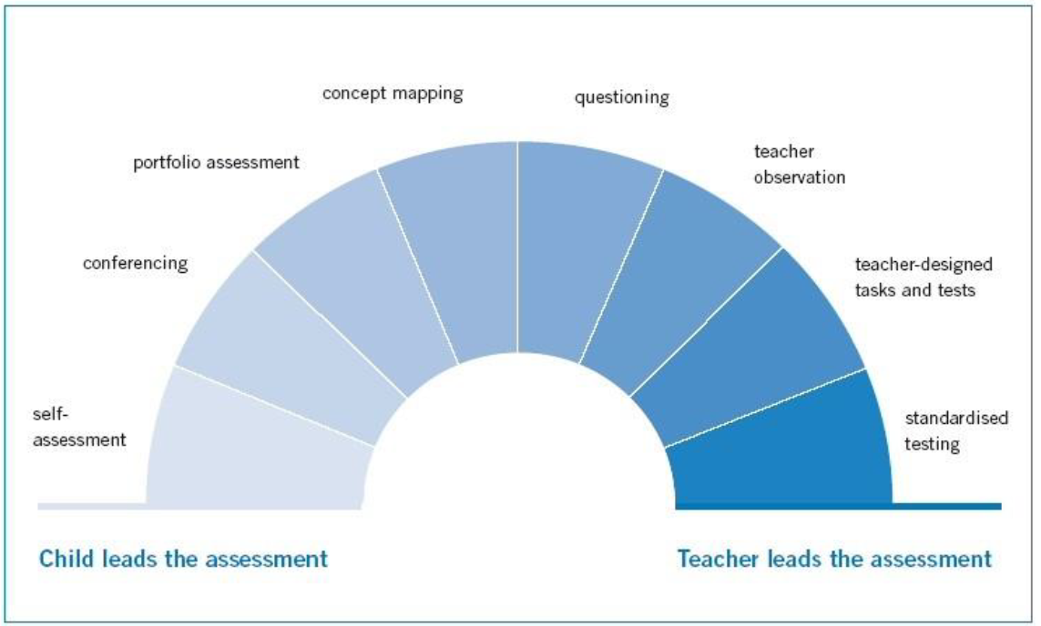
Ref: Assessment in the Primary School, Teacher Guidelines. Figure 2: A continuum of assessment methods
A number of the following assessment methods are used in the school:
- teacher observation e.g. children's response to questioning
- conversation
- questioning
- teacher-designed tasks and test
- checklists
- work samples, portfolios and projects
- concept mapping, e.g. topic brainstorming, creative writing
- self-assessment
- conferencing e.g. teacher/teacher, parent/teacher, teacher/pupil

4.2 Assessment of Learning (AfL)
Throughout the year, teachers use evidence on an ongoing basis to inform teaching and learning. Information of AfL is usually gathered as part of the classroom routine, without breaking the flow of teaching and learning, e.g. through:
- conversation
- question and answer session
- teacher-design tasks or tests (oral/written)
- in-class observation
It also involves children reflecting on, and assessing, his or own work, e.g. through:
- portfolio of public assignments
- work samples
- project work
- artwork

4.3 Assessment of learning (AoL)
Teachers periodically record children's progress and achievements for the purpose of reporting to parents, teachers and others as relevant, as well as informing their own planning. AoL generally takes place at the end of a learning period , using a variety of teacher - led tools where the children is aware that he/she is being accessed, e.g.
- spelling tests
- standardised tests
- questioning
- observation
- teacher-design tasks or tests (end-of-topic/term/year)
While all assessment information should lead to improvement in the child's learning, the purpose of AoL is often used to determine the extent to which curriculum objectives have been met. The Class Teacher uses the information in different ways to plan the next steps, e.g. need for revision of new concept in mathematics. This is useful for all teachers throughout the year, but also at the end of the year as part of the planning process for the next year.
Aggregated information from standardized tests helping whole-school planning in Literacy and Numeracy, both for general planning and Special Educational Needs (SEN) Support.
Information from AoL is also used to inform parent/teacher discussions, as well as in the compilation of new end-of-year reports, etc.

4.4 Standardised tests
Both the Drumcondra Primary Reading Test and the Drumcondra Primary Maths Test (revised) are administered to all classes from 1st to 6th class in May of each school year.
The Special Educational Needs (SEN) Support Team, led by Heather Jordan (ISM team member), is responsible for the coordination, implementation and recording of all testing. A member of the SET support team leads the administration of the standardized Maths and Reading Tests in their respective classrooms. Under the terms of Circular 0138/2006, consideration is given to the appropriateness of these tests for pupils whose additional educational needs prevent them from attempting them. A member of the SET Support Team will usually administer the test of pupils with additional needs, or pupils who have missed the test due to illness, etc. Raw scores, standard scores, percentile ranks, STen scores and reading age are all recorded.
Class Teachers analyse class results, and the principle and the SET support team analyse whole-school results. These results are used to inform parents and Class Teachers, as well as whole-school planning and planning for SET support.
Standardised testing procedures and scoring are explained to parents at the class information meetings at the beginning of each year. The results have a direct bearing on the deployment of teachers and the allocation of SET Support. Results are communicated to parents in the end-of-year School Report. STen scores are used for the purposes of reporting to parents, and explanatory/information documents from NCCA are provided.

4.5 Screening
The Belfield Test is it administered to Junior Infants and the Middle Infants Screening Test (MIST) is administered to Senior Infants in the second term by the class teacher (or SET Support Teacher in the event of absence). The Test 2R is used for targeted children. The results are interpreted by the class teacher and the SET Support Team. Early intervention programs are put in place to support pupils who present with difficulties. Results are communicated to parents on request. Further diagnostic testing will take place, if necessary, following consultation and discussion between the Class Teacher and parents. The New Non-Reading Intelligence Test (NNRIT) is administered to all 2nd class pupils.

4.6 Diagnostic assessment
The formal diagnostic tests used to determine the appropriate learning support for individual pupils who present with learning difficulties are:
- The Neale Analysis of Reading Ability
- The Aston Index of Phonemic Awareness
- Daniels and Diack selected tests
- MIST (senior infants)
- France - Profile of Mathematical Skills
- Maths Tracker CD
- Phab - test of phonological skills
- the DST Dyslexia Screener
- YARC - York Assessment of Reading Comprehension
- SWST - single words spelling test
- SWRT - single word reading test
- Belfield test
- Test 2R
Pupils are selected for diagnostic assessment following consultation between the Class Teacher, SET Support Teachers, Principal and parents. This procedure will usually commence following a period of classroom support (Stage One Intervention). Parents’ verbal permission is sought before diagnostic assessment takes place. The procedures for conducting diagnostic assessments are communicated to teachers and parents
The SET Support Teacher administers and interprets the results of diagnostic testing. If a pupil requires learning support (Stage Two Intervention), the results of the diagnostic assessments are used to inform ILPs. In selecting pupils for supplementary teaching, priority is given to pupils scoring below 12th percentile in English and 12th percentile in Maths. Additional supplementary support will be allocated based on personnel and resources available. The Principal, in consultation with the Class Teacher, SET Support Teachers and parents, will arrange to consult the NEPS psychologist if the results of the diagnostic assessment indicate that further assessment is necessary. Parents will be responsible for arranging consultations with private agencies

4.7 Psychological assessment
The SET Support Teacher, Class Teacher and Principal may all be involved when liaising with parents, if it is felt that a psychological assessment or other assessment is required (Stage Three Intervention). A meeting with parents would be requested. The principal in consultation with teachers and parents would contact NEPS. Any other referrals will be made by parents e.g. Speech and Language Therapist, Audiologist etc. The recommendations from the assessments will inform SSP. Psychological Reports are stored in the Principal’s office and are available on Aladdin under the child's profile. Additional resources are requested, if appropriate, through the National Council for Special Education (NCSE).

4.8 Recording the results of assessment
Standardised test results are recorded by the SET Support Teacher and copied to the Class Teacher who uploads them to the Aladdin database. There is an agreed terminology used and understood by all teachers. Teachers are made aware of the need to record comments in an objective and instructive manner. Confidential files are stored in the Principal’s office.
Appropriate information based on assessments is transferred from class teacher to class teacher at the end of each school year.

5. Roles and responsibilities
All teaching staff has a collective responsibility to implement this policy. The Principal and the SET support team have particular responsibility for the coordination of the policy throughout the school.

6. Ratification and communication
This policy was prepared in conjunction with all staff and was presented to the Board of Management for ratification. A copy of the policy was circulated to all teachers and is made available on the school website. The policy will be made available to the Department of Education and Skills and the school’s patron on request.

7. Implementation
7.1 Roles and responsibilities
This plan was developed by a team of teachers, coordinated by member of the ISM Team, in consultation with the principal and developed through collaboration with all teaching staff, in consultation with the Board of Management and parent representatives. The policy is implemented by all staff throughout the school and is reflected in all individual teachers long and short-term planning.
7.2 Timeframe
This policy is implemented immediately following its ratification by the Board of Management.

8. Success criteria
This policy supports consistent and reliable assessment both AoL and AfL, throughout the school as outlined in the Primary Curriculum and Assessment in the Primary School Teacher Guidelines. Its successful implementation is monitored through:
- Teachers’ preparation and record keeping
- ensuring the procedures are consistently followed
- the end product as seen directly through the children's work
Indicators of the success of this policy include:
- a range of informal and formal assessment modes are used to place assessment as an integral part of teaching and learning
- procedures run smoothly and efficiently because there is clarity about what is expected and who is responsible for different aspects of the process.
- transfer of information from class teacher to class teacher, and between Class and SET Support Teachers as happens continually throughout the school year
The outcomes of the policy are assessed through:
- feedback from teachers, parents and pupils
- inspector suggestions and reports
- and feedback from second levels schools following pupil transfer

9. Review
9.1 Roles and Responsibilities
Under the leadership of a member of the In-School Management (ISM) Team, those involved in the review will include representatives of the SET Support Team, Class Teachers, the Board of Management, parents and pupils (where appropriate). Pupils work will assist in informing the review process and feedback from parents will help informing the review. Subject coordinator(s), in consultation with the principal, are responsible for checking that tasks have been completed in accordance with agreed timeframes.

9.2 Time frame
It will be necessary to review this plan on a regular basis to ensure optimal implementation of an Assessment program in the school. A full review of the policy would be scheduled for 2023

Signed: ____________________________ Signed: _________________________
Canon David Mungavin Rachel Harper
Chairperson Board of Management Principal

Date: Date:

